CMPG 311

29161029 M.I Ralekula

**Question 4**

**i)**

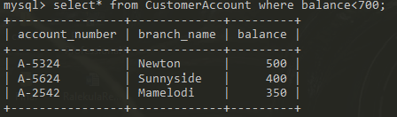

**ii)**

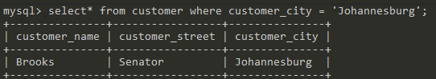

**iii)**

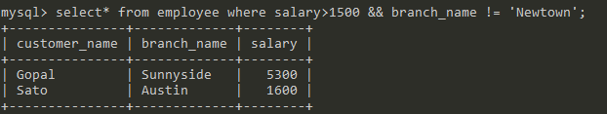

**iv)**

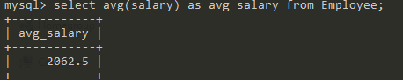

**V)**

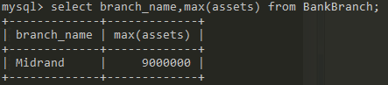

**Question 5**

1. SELECT* FROM Employees Where branch_name = ‘Sunnyside’;
2. SELECT * FROM Borrowers;
3. SELECT account_number FROM CustomerAccount WHERE balance > 900;
4. SELECT account_number, balance FROM CustomerAccount WHERE balance > 600 && branch_name = ’NewTown’;
5. SELECT branch_name, assets FROM BankBranch;